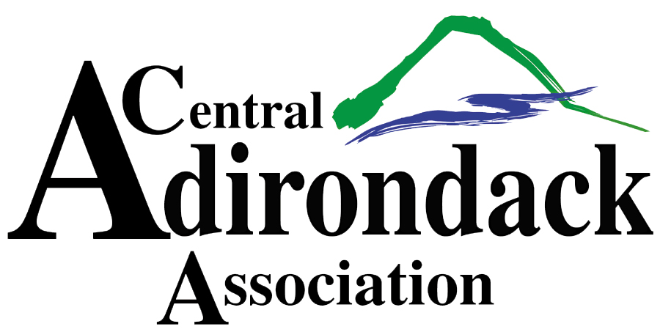
SNOFEST VENDOR APPLICATION
March 8th & 9th, 2024

To request space, please fill out the form below and return with payment to the CAA, PO Box 68, Old Forge, NY 13420 or email to laurieb@caany.com, no later than February 10th.
- Booth set up time will be Thursday, 3/7, from 9am – 5pm ONLY.
- Hours of operation are Friday, 3/8, from 9am – 5pm and Saturday, 3/9, from 9am – 5pm. All vendors must be set up and ready for operation by 9am, March 8th.
- The pavilion will close at approximately 5pm on Saturday, March 9th. Breakdown will begin at that time, no sooner. Merchandise must be removed from the pavilion by 9pm.
- No running machines in pavilion. Vendors are NOT allowed to sell raffle tickets of any kind.
- All vendors must provide a certificate of insurance listing the Town of Webb, PO Box 157, Old Forge, NY, 13420 and the Central Adirondack Association, PO Box 68, Old Forge, NY, 13420, additional insured. Please return certificates with application.
- Payments must be received in full with application. Make checks payable to the Central Adirondack Association and mail to the address above.
- No set up allowed until booth fee paid in full prior to event opening.
- One 8 ft table and 2 chairs are available if needed. WIFI available.
- NO REFUNDS. $400.00 per 10 x 20 interior booth space.
If you have any questions please contact Laurie Barkauskas at laurieb@caany.com or 315-369-6983 x-23. Please visit www.Snofest.com for more info, weekend events and vendor list.
BOOTH SPACE REQUEST FOR SNOFEST 2024
Business name:___________________________________ Phone:_____________________________
Address:______________________________________________________________________________
Contact name:____________________________________ Email:______________________________
Name of person responsible for booth:_____________________________________________________
Products sold:_________________________________________________________________________
Signature:_______________________________________ Date:_______________________________
Number of 10 X 20 interior booth spaces ($400): ________

